**Lab 6**

1. **Working with the dplyr package**

For this part and the next, you should work with the file dail2002.dta from the article Kenneth Benoit and Michael Marsh. 2008. “[The Campaign Value of Incumbency: A New Solution to the Puzzle of Less Effective Incumbent Spending.](http://www.kenbenoit.net/pdfs/ajps_348.pdf)” American Journal of Political Science52(4, October): 874-890.

1. Load the Stata dataset used in this paper, available [here](http://www.kenbenoit.net/files/dail2002.dta) (<http://www.kenbenoit.net/files/dail2002.dta>). To load this into R, you will need the read.dta command from the foreign package. (Note that you can load straight from the URL using this command.) Call this data object dail2002. What sort of object is this? How can you tell what sort of object it is?

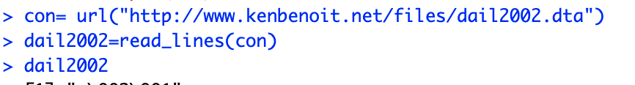

or

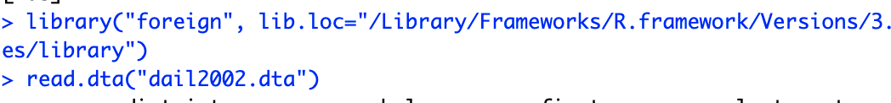

1. Filtering: Select only the Fianna Fail candidates using filter(), and assign the filtered data.frame to dail2002FF. Note that you might want to first find out what are the labels for party by using summary() on the party variable.

How many FF were there in the 2002 election?

1. Summarizing FF candidates per constituency. On the new data frame dail2002FF, summarize the median spending (spend_total) for FF candidates using the dplyr function summarise. Use “pipes” when possible. Do the same using aggregate instead of dplyr.
2. **Working with the reshape2 package**
3. The count2 - count16 variables are currently in “wide” format. Use melt to create a candidate-count unit dataset, and then produce a table of the 42 constituencies by their maximum count.
4. Hint: First melt the data using reshape2, creating a new variable called count for the new value. Then filter to remove any count variable that is zero. Then group_byconstituency, and summarise a count using max().